Use Case No. 3

|  |  |  |
| --- | --- | --- |
| Use Case | Sign-up | |
| Objective | View Company’s ‘About Us’ page and sign-up. | |
| Business Event | View Company’s ‘About Us’ page and sign-up. | |
| Primary Actor (s) | Customer. | |
| Secondary Actor (s) | None. | |
| Pre-condition | User must be logged into the system.  User must click on the ‘About Us’ page. | |
| Post-condition | User is on the subscribe form.  User is forwarded to the Home Page after clicking ‘Sign-up’ button. | |
| Failure outcomes | User is on the fill out review form.  User is shown an error message ‘Existing username’. | |
| Flow of Events | Actor | System |
| 1 | User is on the home page (home-page.php).  User clicks on the About Us page(about-us.php). | Home page is shown. |
| 2 | User is directed to the Sign-up form. | About us page is shown. |
| 3 | User submits the form. | Prompts Sign-up form. |
| 4 | User is taken back to the home page. | Takes user back to Home page, sends confirmation. |

Activity Diagram

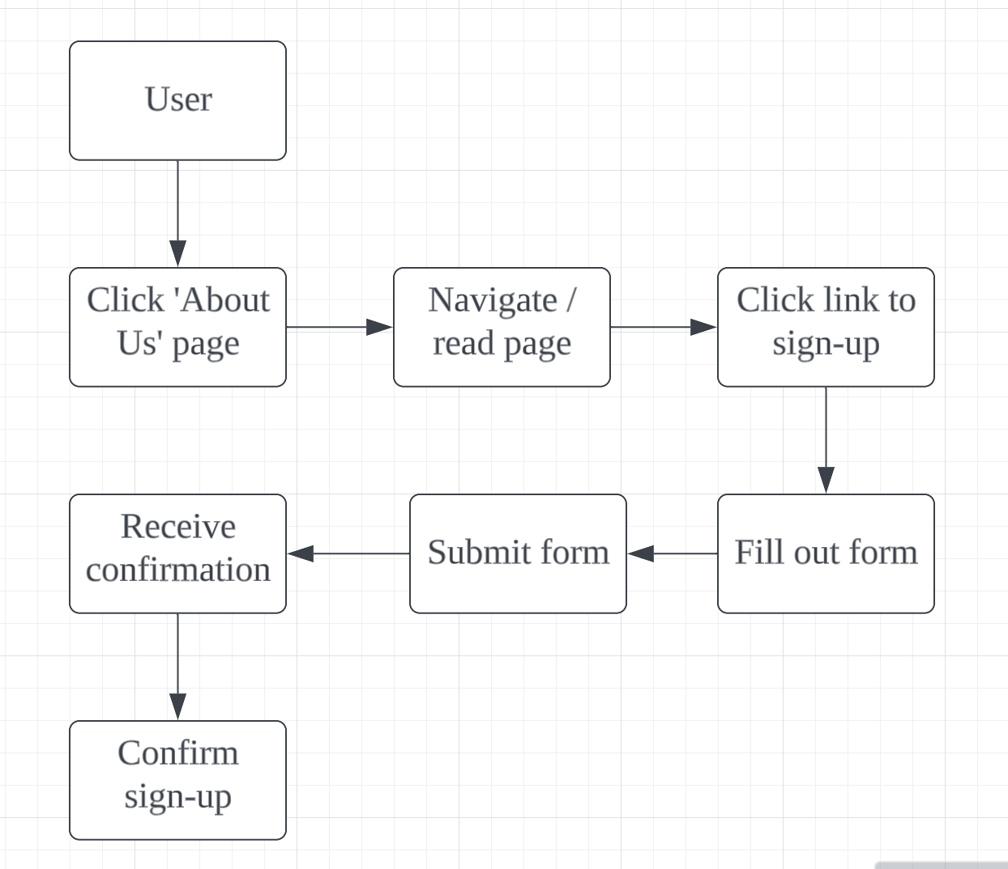

Wire Diagram

